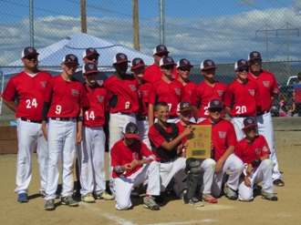
Lessons for politicians from 12-year-olds

In baseball…
You- can’t lie
You- can't cheat
You- can’t whine
You- can’t throw equipment

In baseball…
You- abide by authority
You- follow rules
You- respect the opposition
You- salute the flag in the proper way
You- work as one
You- have no ego
You- play as one
You- are scored by your measured outcomes
You- act civilly
You- support others when they're down

Haven’t politicians played baseball?

